

Capstone Project Report
Report 3 – Software Requirement Specification

– Hanoi, August 2019 –
Table of Contents
I. Record of Changes 3
II. Software Requirement Specification 4
1. Product Overview 4
2. User Requirements 5
2.1 Actors 5
2.2 Use Cases 5
3. Functional Requirements 6
3.1 System Functional Overview 6
3.2 <<Feature Name 1>> 7
3.3 <<Feature Name 2>> 8
4. Non-Functional Requirements 9
4.1 External Interfaces 9
4.2 Quality Attributes 9
5. Requirement Appendix 10
5.1 Business Rules 10
5.2 Common Requirements 10
5.3 Application Messages List 10
5.4 Other Requirements… 11

I. Record of Changes
Date | A*  M, D | In charge | Change Description
*A - Added M - Modified D - Deleted

II. Software Requirement Specification

1. Product Overview
[Gives the overall description about the product with some introduction and the context diagram. The context diagram presents the boundary and connections between the system you’re developing and everything else in the universe. This identifies external entities (or terminators – software, hardware, human components, and other systems) outside the system that interface to it in some way, as well as data, control, and material flows between the terminators and the system.]
<<Sample: The Cafeteria Ordering System is a new software system that replaces the current manual and telephone processes for ordering and picking up meals in the Process Impact cafeteria. The context diagram below illustrates the external entities and system interfaces for release 1.0. The system is expected to evolve over several releases, ultimately connecting to the Internet ordering services for several local restaurants and to credit and debit card authorization services.
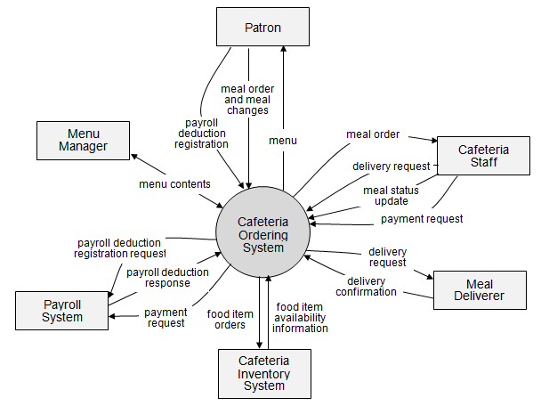
>>

2. User Requirements

2.1 Actors
[An actor is a person (or sometimes another software system or a hardware device) that interacts with the system to perform a use case. Following are some questions you might ask to help user representatives identify actors
- Who (or what) is notified when something occurs within the system?
- Who (or what) provides information or services to the system?
- Who (or what) helps the system respond to and complete a task?
This part gives the description of system actors, you can follow the table form as below]
# | Actor | Description
1 | Administrator
2 | Menu Manager
3 | …

2.2 Use Cases
[A use case (UC) describes a sequence of interactions between a system and an external actor that results in the actor being able to achieve some outcome of value. The names of use cases are always written in the form of a verb followed by an object. Select strong, descriptive names to make it evident from the name that the use case will deliver something valuable for some user]

2.2.1 Diagram(s)
[Provide the UC diagram(s) to show the actor-UCs and UC-UC relationships like the sample below. You can have multiple UC diagrams for the system]
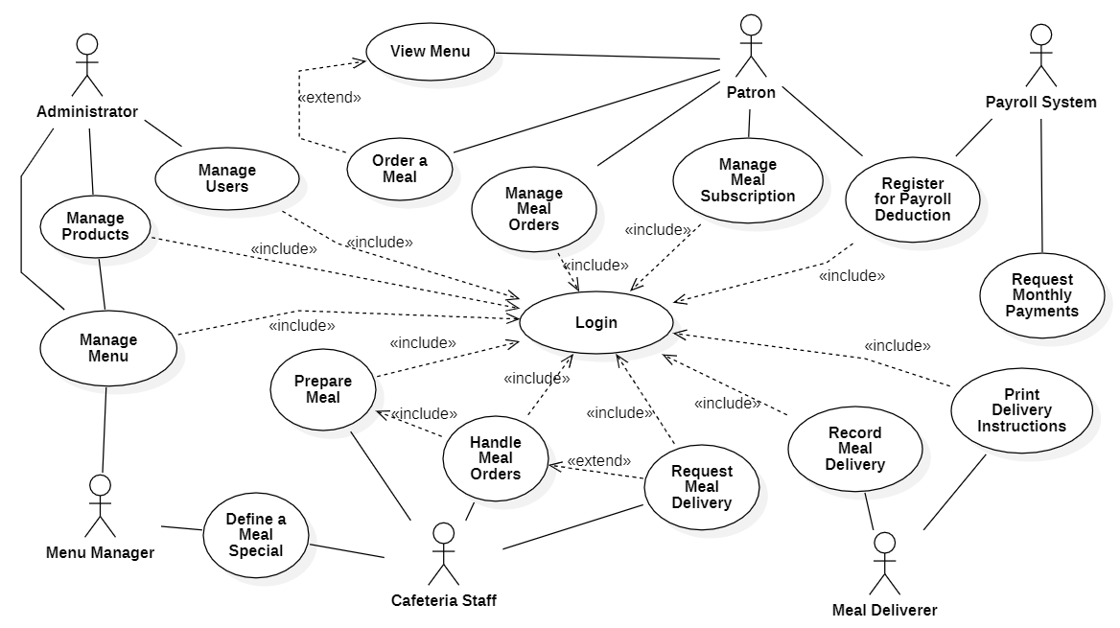

2.2.2 Descriptions
This part describes the use cases, you can follow the table form as below]
ID | Use Case | Actors | Use Case Description
01 | View Menu | Patron
02 | Order a Meal | Patron
03 | …

3. Functional Requirements

3.1 System Functional Overview

3.1.1 Screens Flow

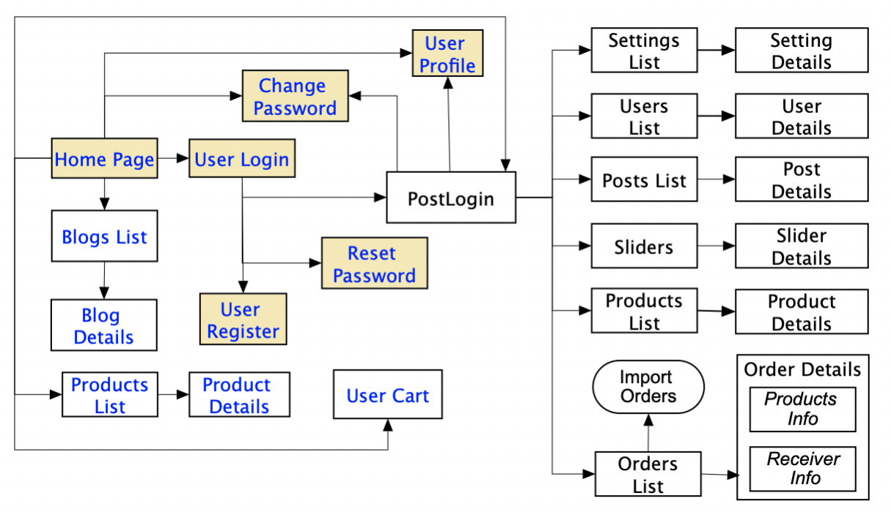

3.1.2 Screen Descriptions
# | Feature | Screen | Description
1 | Order Meals | Create Order | <<Screen Brief description>>
2 | Order Meals | Change Order
3 | ..

3.1.3 Screen Authorization
Screen | Role-Name1 | Role-Name2 | Role-Name3 | …
<<Screen Name1>> | X |  | X | X
<<Screen Activity>> |  |  | X | X
<<Screen Name2>> | X |  | X
Query All Data | X
Query Own Data |  |  | X
Query Managed Data |  |  | X
Add New Data |  |  | X | X
Update All Data |  |  |  | X
Update Own Data |  |  |  | X
Update Managed Data |  |  |  | X
Delete Data
…

3.1.4 Non-Screen Functions
# | Feature | System Function | Description
1 | <<Feature Name>> | <<Function Name1>> | <<Function Name1 Description>>
2 | …

3.1.5 Entity Relationship Diagram
Entities Description
# | Entity | Description
1 | User
2 | Meal
3 | Meal Subscription
4 | …

3.2 <<Feature Name 1>>

3.2.1 <<Function Name 1>>
[A function can be a screen or a non-screen function (listed in the part 3.1.5 above). In this part, you need to provide the details on the related function, focus on mentioning below information
- Function trigger: how this function is triggered (navigation path, a timing frequency, etc.
- Function description: actors/roles, purpose, interface, data processing, etc.
- Screen layout: mock-up prototype of the screen, sample below is for Manage Products screen
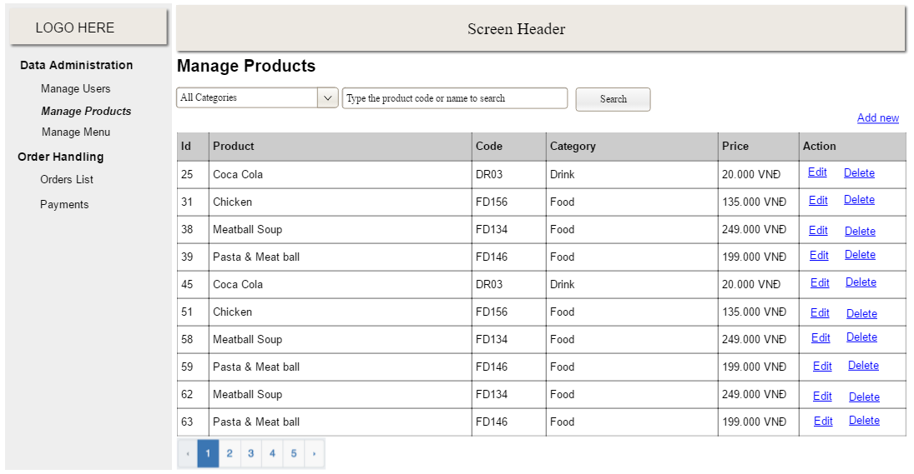
- Function Details: provide explanation for the data, validation, business rules, functionalities (for both normal cases and abnormal cases), etc. of the function so that the reader can image how it work.
]

3.2.2 <<Function Name 2>>
…

3.3 <<Feature Name 2>>
…

4. Non-Functional Requirements

4.1 External Interfaces
[This section provides information to ensure that the system will communicate properly with users and with external hardware or software/system elements.]

4.2 Quality Attributes
[List all the required system characteristics (quality attributes) specification. Some of the possible attributes are provided with the guide/descriptions are mentioned here]

4.2.1 Usability
[This section includes all those requirements that affect usability. For example, specify the required training time for a normal users and a power user to become productive at particular operations specify measurable task times for typical tasks or base the new system’s usability requirements on other systems that the users know and like specify requirement to conform to common usability standards, such as IBM’s CUA standards Microsoft’s GUI standards]

4.2.2 Reliability
[Requirements for reliability of the system should be specified here. Some suggestions follow:
Availability—specify the percentage of time available ( xx.xx%), hours of use, maintenance access, degraded mode operations, and so on.
Mean Time Between Failures (MTBF) — this is usually specified in hours, but it could also be specified in terms of days, months or years.
Mean Time To Repair (MTTR)—how long is the system allowed to be out of operation after it has failed?
Accuracy—specifies precision (resolution) and accuracy (by some known standard) that is required in the system’s output.
Maximum Bugs or Defect Rate—usually expressed in terms of bugs per thousand lines of code (bugs/KLOC) or bugs per function-point( bugs/function-point).
Bugs or Defect Rate—categorized in terms of minor, significant, and critical bugs: the requirement(s) must define what is meant by a “critical” bug; for example, complete loss of data or a complete inability to use certain parts of the system’s functionality.]

4.2.3 Performance
[The system’s performance characteristics are outlined in this section. Include specific response times. Where applicable, reference related Use Cases by name.
Response time for a transaction (average, maximum)
Throughput, for example, transactions per second
Capacity, for example, the number of customers or transactions the system can accommodate
Resource utilization, such as memory, disk, communications, and so forth.]

4.2.4 …

5. Requirement Appendix
[Provide business rules, common requirements, or other extra requirements information here]

5.1 Business Rules
[Provide common business rules that you must follow. The information can be provided in the table format as the sample below]
ID | Rule Definition
BR-01 | Delivery time windows are 15 minutes, beginning on each quarter hour.
BR-02 | Deliveries must be completed between 10:00 A.M. and 2:00 P.M. local time, inclusive.
BR-03 | All meals in a single order must be delivered to the same location.
BR-04 | All meals in a single order must be paid for by using the same payment method.
BR-11 | If an order is to be delivered, the patron must pay by payroll deduction.
BR-12 | Order price is calculated as the sum of each food item price times the quantity of that food item ordered, plus applicable sales tax, plus a delivery charge if a meal is delivered outside the free delivery zone.
BR-24 | Only cafeteria employees who are designated as Menu Managers by the Cafeteria Manager can create, modify, or delete cafeteria menus.
BR-33 | Network transmissions that involve financial information or personally identifiable information require 256-bit encryption.
BR-86 | Only regular employees can register for payroll deduction for any company purchase.
BR-88 | An employee can register for payroll deduction payment of cafeteria meals if no more than 40 percent of his gross pay is currently being deducted for other reasons.

5.2 Common Requirements
[Fill all the common requirements here..]

5.3 Application Messages List
# | Message code | Message Type | Context | Content
1 | MSG01 | In line | There is not any search result | No search results.
2 | MSG02 | In red, under the text box | Input-required fields are empty | The * field is required.
3 | MSG03 | Toast message | Updating asset(s) information successfully | Update asset(s) successfully.
4 | MSG04 | Toast message | Adding new asset successfully | Add asset successfully.
5 | MSG05 | Toast message | Confirming email of asset hand-over is sent successfully | A confirmation email has been sent to {email_address}.
6 | MSG06 | Toast message | Resetting asset information successfully | Return asset(s) successfully.
7 | MSG07 | Toast message | Deleting asset information successfully | Delete asset(s) successfully.
8 | MSG08 | In red, under the text box | Input value length > max length | Exceed max length of {max_length}.
9 | MSG09 | In line | Username or password is not correct when clicking sign-in | Incorrrect user name or password. Please check again.

5.4 Other Requirements…

